ЛДПК Филиал ГГТУ
Отчёт по практическому заданию
Кейс №7 Стартап «HealthTrack»
Мелконян Тигран Артурович

Ux-макеты
Ux-макет разработан в Figma: три экрана – вход, дашборд и мобильная версия
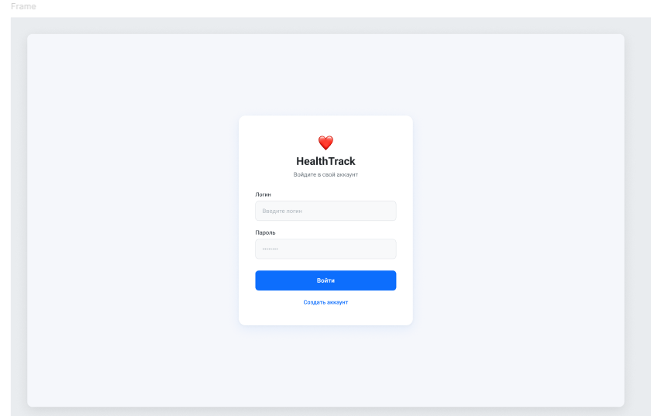
Рис. 1 «Экран входа»
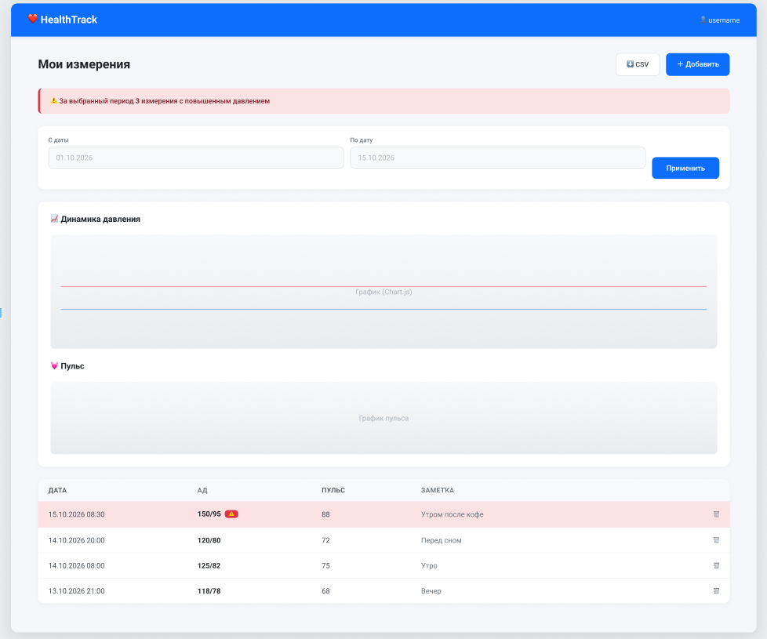
Рис. 2 «Дашборд»
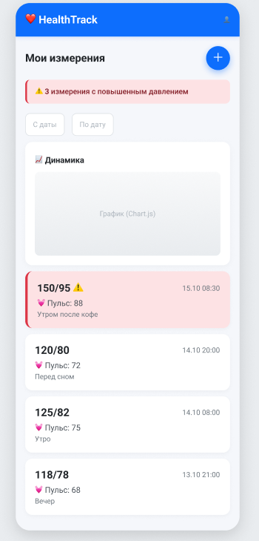
Рис. 3 «Адаптивная мобильная версия»
Модель БД
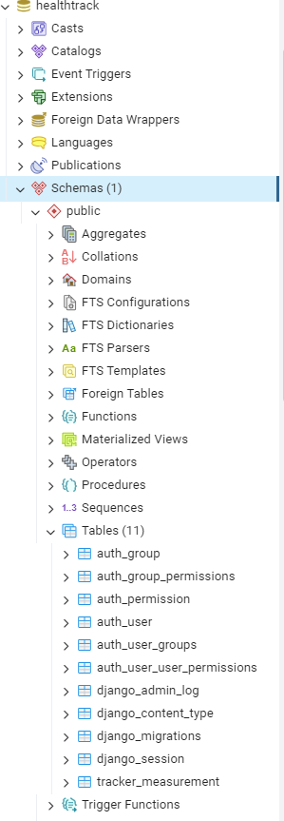
Рис. 4 «Структура бд в pgAdmin»
Работа приложения
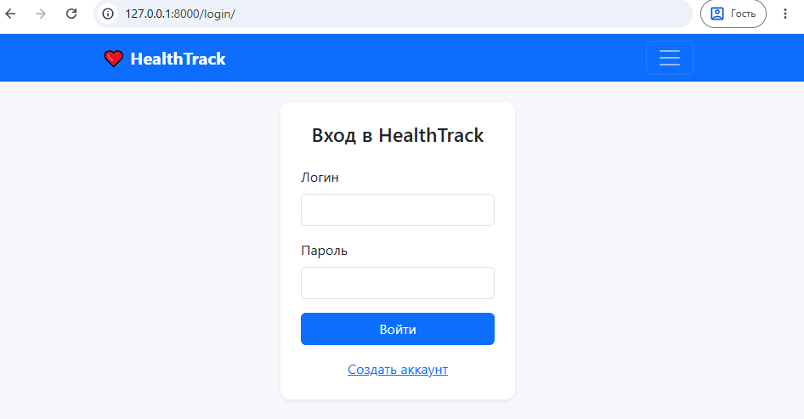
Рис. 5 «Вход»
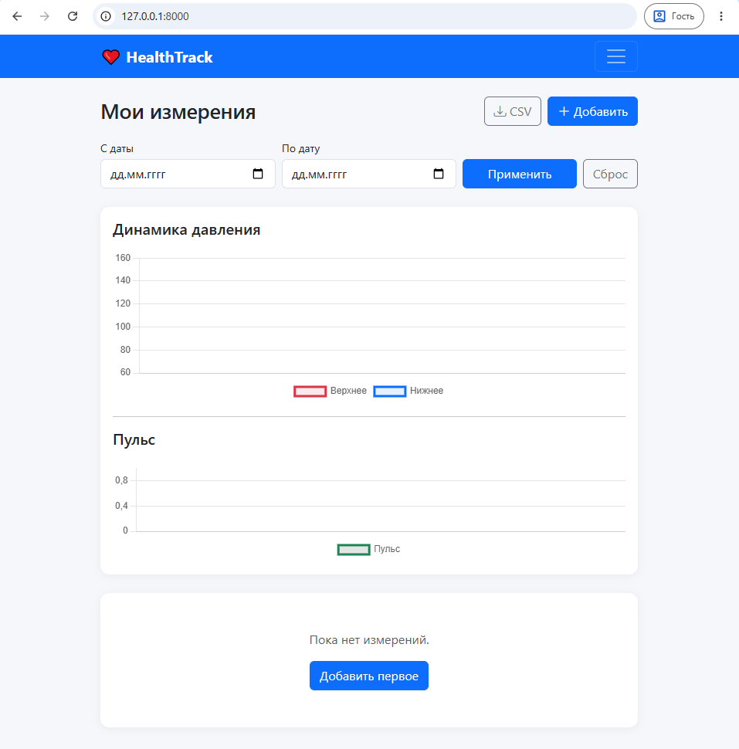
Рис. 6 «Главный экран»
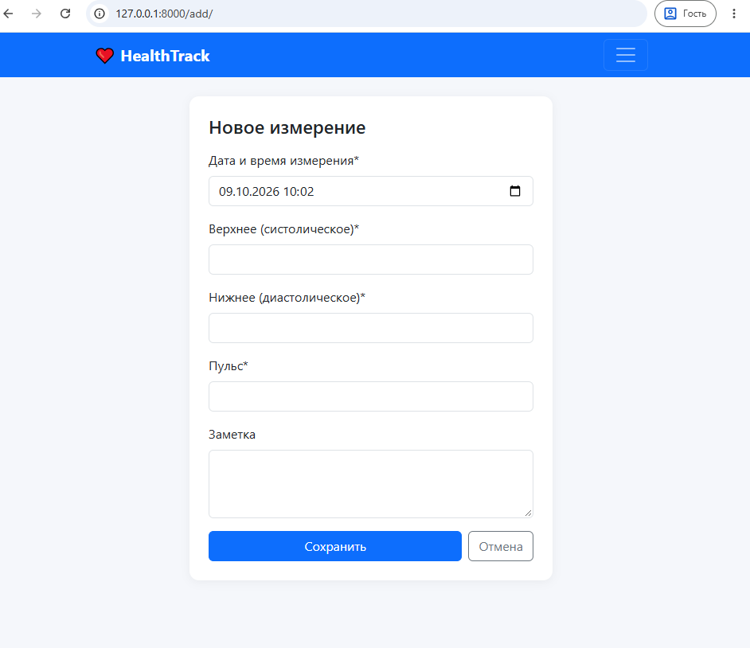
Рис. 7 «Форма добавления»
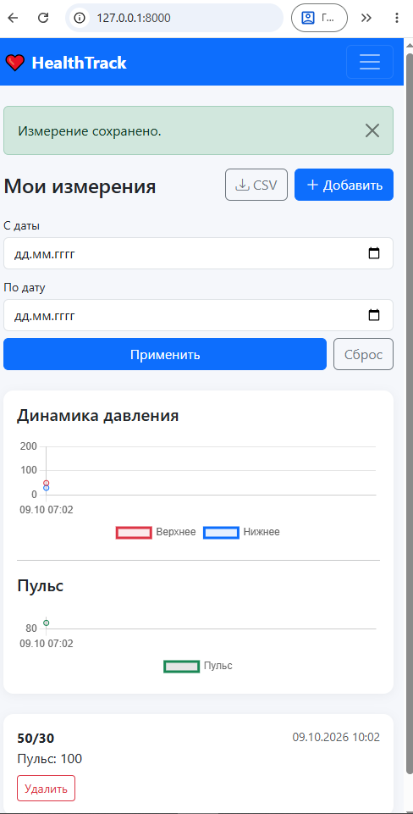
Рис. 8 «Мобильная версия»
Коды
Healthtrack/urls.py
from django.contrib import admin
from django.urls import path, include

urlpatterns = [
path('admin/', admin.site.urls),
path('', include('tracker.urls')),
]
tracker/forms.py
from django import forms
from django.contrib.auth.forms import UserCreationForm
from django.contrib.auth.models import User
from .models import Measurement

class MeasurementForm(forms.ModelForm):
class Meta:
model = Measurement
fields = ['measured_at', 'systolic', 'diastolic', 'pulse', 'note']
widgets = {
'measured_at': forms.DateTimeInput(
attrs={'type': 'datetime-local', 'class': 'form-control'},
format='%Y-%m-%dT%H:%M',
),
'systolic': forms.NumberInput(attrs={'class': 'form-control'}),
'diastolic': forms.NumberInput(attrs={'class': 'form-control'}),
'pulse': forms.NumberInput(attrs={'class': 'form-control'}),
'note': forms.Textarea(attrs={'rows': 3, 'class': 'form-control'}),
}

def __init__(self, *args, **kwargs):
super().__init__(*args, **kwargs)
self.fields['measured_at'].input_formats = ['%Y-%m-%dT%H:%M']

def clean(self):
cleaned = super().clean()
s, d = cleaned.get('systolic'), cleaned.get('diastolic')
if s and d and s <= d:
raise forms.ValidationError('Верхнее давление должно быть больше нижнего.')
return cleaned

class RegisterForm(UserCreationForm):
email = forms.EmailField(required=False)

class Meta:
model = User
fields = ['username', 'email', 'password1', 'password2']

def __init__(self, *args, **kwargs):
super().__init__(*args, **kwargs)
for f in self.fields.values():
f.widget.attrs.update({'class': 'form-control'})
tracker/models.py
from django.conf import settings
from django.db import models
from django.core.validators import MinValueValidator, MaxValueValidator
from django.utils import timezone

class Measurement(models.Model):
user = models.ForeignKey(
settings.AUTH_USER_MODEL,
on_delete=models.CASCADE,
related_name='measurements',
verbose_name='Пользователь',
)
measured_at = models.DateTimeField(
default=timezone.now,
verbose_name='Дата и время измерения',
)
systolic = models.PositiveSmallIntegerField(
validators=[MinValueValidator(50), MaxValueValidator(300)],
verbose_name='Верхнее (систолическое)',
)
diastolic = models.PositiveSmallIntegerField(
validators=[MinValueValidator(30), MaxValueValidator(200)],
verbose_name='Нижнее (диастолическое)',
)
pulse = models.PositiveSmallIntegerField(
validators=[MinValueValidator(30), MaxValueValidator(220)],
verbose_name='Пульс',
)
note = models.TextField(blank=True, verbose_name='Заметка')
created_at = models.DateTimeField(auto_now_add=True)

class Meta:
ordering = ['-measured_at']
verbose_name = 'Измерение'
verbose_name_plural = 'Измерения'
indexes = [models.Index(fields=['user', '-measured_at'])]

def __str__(self):
return f'{self.measured_at:%d.%m.%Y %H:%M} — {self.systolic}/{self.diastolic}'

@property
def is_hypertensive(self) -> bool:
return self.systolic > 140 or self.diastolic > 90

@property
def is_pulse_abnormal(self) -> bool:
return self.pulse > 100 or self.pulse < 50

@property
def status(self) -> str:
if self.is_hypertensive:
return 'danger'
if self.is_pulse_abnormal:
return 'warning'
return 'normal'
tracker/urls.py
from django.urls import path
from django.contrib.auth import views as auth_views
from . import views

urlpatterns = [
path('', views.dashboard, name='dashboard'),
path('add/', views.measurement_add, name='measurement_add'),
path('delete/<int:pk>/', views.measurement_delete, name='measurement_delete'),
path('export/', views.export_csv, name='export_csv'),

path('register/', views.register, name='register'),
path('login/', auth_views.LoginView.as_view(template_name='tracker/login.html'), name='login'),
path('logout/', auth_views.LogoutView.as_view(), name='logout'),
]
tracker/views.py
import csv
from datetime import datetime

from django.contrib.auth import login
from django.contrib.auth.decorators import login_required
from django.contrib import messages
from django.db.models import Q
from django.http import HttpResponse
from django.shortcuts import render, redirect
from django.utils import timezone

from .forms import MeasurementForm, RegisterForm
from .models import Measurement

def register(request):
if request.method == 'POST':
form = RegisterForm(request.POST)
if form.is_valid():
user = form.save()
login(request, user)
messages.success(request, f'Добро пожаловать, {user.username}!')
return redirect('dashboard')
else:
form = RegisterForm()
return render(request, 'tracker/register.html', {'form': form})

@login_required
def dashboard(request):
qs = Measurement.objects.filter(user=request.user)

date_from = request.GET.get('date_from')
date_to = request.GET.get('date_to')

if date_from:
try:
qs = qs.filter(measured_at__date__gte=datetime.strptime(date_from, '%Y-%m-%d'))
except ValueError:
pass
if date_to:
try:
qs = qs.filter(measured_at__date__lte=datetime.strptime(date_to, '%Y-%m-%d'))
except ValueError:
pass

chart_qs = list(qs.order_by('measured_at')[:100])
chart_data = {
'labels': [m.measured_at.strftime('%d.%m %H:%M') for m in chart_qs],
'systolic': [m.systolic for m in chart_qs],
'diastolic': [m.diastolic for m in chart_qs],
'pulse': [m.pulse for m in chart_qs],
}

context = {
'measurements': qs[:200],
'chart_data': chart_data,
'date_from': date_from or '',
'date_to': date_to or '',
'danger_count': qs.filter(Q(systolic__gt=140) | Q(diastolic__gt=90)).count(),
}
return render(request, 'tracker/dashboard.html', context)

@login_required
def measurement_add(request):
if request.method == 'POST':
form = MeasurementForm(request.POST)
if form.is_valid():
obj = form.save(commit=False)
obj.user = request.user
obj.save()
if obj.is_hypertensive:
messages.warning(request, '⚠ Внимание! Давление выше нормы (140/90).')
else:
messages.success(request, 'Измерение сохранено.')
return redirect('dashboard')
else:
form = MeasurementForm(initial={'measured_at': timezone.now()})
return render(request, 'tracker/measurement_form.html', {'form': form})

@login_required
def measurement_delete(request, pk):
Measurement.objects.filter(pk=pk, user=request.user).delete()
messages.info(request, 'Измерение удалено.')
return redirect('dashboard')

@login_required
def export_csv(request):
qs = Measurement.objects.filter(user=request.user).order_by('-measured_at')
response = HttpResponse(content_type='text/csv; charset=utf-8')
response['Content-Disposition'] = 'attachment; filename="measurements.csv"'
response.write('\ufeff')
writer = csv.writer(response, delimiter=';')
writer.writerow(['Дата', 'Верхнее', 'Нижнее', 'Пульс', 'Заметка', 'Статус'])
for m in qs:
writer.writerow([
m.measured_at.strftime('%d.%m.%Y %H:%M'),
m.systolic, m.diastolic, m.pulse,
m.note, 'Высокое' if m.is_hypertensive else 'Норма',
])
return response
templates/tracker/base.html
{% load static %}
<!doctype html>
<html lang="ru">
<head>
<meta charset="utf-8">
<meta name="viewport" content="width=device-width, initial-scale=1">
<title>{% block title %}HealthTrack{% endblock %}</title>
<link href="https://cdn.jsdelivr.net/npm/bootstrap@5.3.3/dist/css/bootstrap.min.css" rel="stylesheet">
<link href="https://cdn.jsdelivr.net/npm/bootstrap-icons@1.11.3/font/bootstrap-icons.css" rel="stylesheet">
<style>
body { background: #f5f7fb; }
.navbar-brand { font-weight: 700; }
.card { border: none; box-shadow: 0 2px 12px rgba(0,0,0,.05); border-radius: 12px; }
.table-danger { background-color: #fde2e4 !important; }
.table-warning { background-color: #fff3cd !important; }
</style>
</head>
<body>
<nav class="navbar navbar-expand-lg navbar-dark bg-primary mb-4">
<div class="container">
<a class="navbar-brand" href="{% url 'dashboard' %}">❤️ HealthTrack</a>
<button class="navbar-toggler" data-bs-toggle="collapse" data-bs-target="#nav">
<span class="navbar-toggler-icon"></span>
</button>
<div class="collapse navbar-collapse" id="nav">
<ul class="navbar-nav ms-auto">
{% if user.is_authenticated %}
<li class="nav-item"><span class="navbar-text text-white me-3">👤 {{ user.username }}</span></li>
<li class="nav-item">
<form method="post" action="{% url 'logout' %}" class="d-inline">{% csrf_token %}
<button class="btn btn-outline-light btn-sm">Выйти</button>
</form>
</li>
{% else %}
<li class="nav-item"><a class="nav-link" href="{% url 'login' %}">Вход</a></li>
<li class="nav-item"><a class="nav-link" href="{% url 'register' %}">Регистрация</a></li>
{% endif %}
</ul>
</div>
</div>
</nav>

<main class="container pb-5">
{% for msg in messages %}
<div class="alert alert-{{ msg.tags|default:'info' }} alert-dismissible fade show">
{{ msg }}
<button class="btn-close" data-bs-dismiss="alert"></button>
</div>
{% endfor %}
{% block content %}{% endblock %}
</main>

<script src="https://cdn.jsdelivr.net/npm/bootstrap@5.3.3/dist/js/bootstrap.bundle.min.js"></script>
<script src="https://cdn.jsdelivr.net/npm/chart.js@4.4.1/dist/chart.umd.min.js"></script>
{% block scripts %}{% endblock %}
</body>
</html>
templates/tracker/dashboard.html
{% extends 'tracker/base.html' %}
{% block content %}

<div class="d-flex flex-wrap justify-content-between align-items-center mb-3 gap-2">
<h1 class="h3 mb-0">Мои измерения</h1>
<div class="d-flex gap-2">
<a href="{% url 'export_csv' %}" class="btn btn-outline-secondary">
<i class="bi bi-download"></i> CSV
</a>
<a href="{% url 'measurement_add' %}" class="btn btn-primary">
<i class="bi bi-plus-lg"></i> Добавить
</a>
</div>
</div>

{% if danger_count %}
<div class="alert alert-danger">
⚠ За выбранный период <strong>{{ danger_count }}</strong> измерений с повышенным давлением.
</div>
{% endif %}

<form class="row g-2 mb-4" method="get">
<div class="col-12 col-md-4">
<label class="form-label small mb-1">С даты</label>
<input type="date" name="date_from" value="{{ date_from }}" class="form-control">
</div>
<div class="col-12 col-md-4">
<label class="form-label small mb-1">По дату</label>
<input type="date" name="date_to" value="{{ date_to }}" class="form-control">
</div>
<div class="col-12 col-md-4 d-flex align-items-end gap-2">
<button class="btn btn-primary flex-grow-1">Применить</button>
<a href="{% url 'dashboard' %}" class="btn btn-outline-secondary">Сброс</a>
</div>
</form>

<div class="card mb-4">
<div class="card-body">
<h5 class="card-title mb-3">Динамика давления</h5>
<canvas id="bpChart" height="90"></canvas>
<hr>
<h5 class="card-title mb-3">Пульс</h5>
<canvas id="pulseChart" height="60"></canvas>
</div>
</div>

<div class="card">
<div class="card-body p-0">
{% if measurements %}
<div class="table-responsive d-none d-md-block">
<table class="table table-hover mb-0 align-middle">
<thead class="table-light">
<tr>
<th>Дата</th><th>АД</th><th>Пульс</th><th>Заметка</th><th></th>
</tr>
</thead>
<tbody>
{% for m in measurements %}
<tr class="{% if m.is_hypertensive %}table-danger{% elif m.is_pulse_abnormal %}table-warning{% endif %}">
<td>{{ m.measured_at|date:"d.m.Y H:i" }}</td>
<td><strong>{{ m.systolic }}/{{ m.diastolic }}</strong>
{% if m.is_hypertensive %}<i class="bi bi-exclamation-triangle-fill text-danger"></i>{% endif %}
</td>
<td>{{ m.pulse }}</td>
<td class="text-truncate" style="max-width:240px">{{ m.note }}</td>
<td class="text-end">
<a href="{% url 'measurement_delete' m.pk %}" class="btn btn-sm btn-outline-danger"
onclick="return confirm('Удалить?')"><i class="bi bi-trash"></i></a>
</td>
</tr>
{% endfor %}
</tbody>
</table>
</div>

<div class="d-md-none">
{% for m in measurements %}
<div class="border-bottom p-3 {% if m.is_hypertensive %}bg-danger-subtle{% elif m.is_pulse_abnormal %}bg-warning-subtle{% endif %}">
<div class="d-flex justify-content-between">
<strong>{{ m.systolic }}/{{ m.diastolic }}</strong>
<small class="text-muted">{{ m.measured_at|date:"d.m.Y H:i" }}</small>
</div>
<div>Пульс: {{ m.pulse }}</div>
{% if m.note %}<div class="small text-muted">{{ m.note }}</div>{% endif %}
<a href="{% url 'measurement_delete' m.pk %}" class="btn btn-sm btn-outline-danger mt-2"
onclick="return confirm('Удалить?')">Удалить</a>
</div>
{% endfor %}
</div>
{% else %}
<div class="text-center p-5 text-muted">
<p>Пока нет измерений.</p>
<a href="{% url 'measurement_add' %}" class="btn btn-primary">Добавить первое</a>
</div>
{% endif %}
</div>
</div>

{{ chart_data|json_script:"chart-data" }}
{% endblock %}

{% block scripts %}
<script>
const chartData = JSON.parse(document.getElementById('chart-data').textContent);

new Chart(document.getElementById('bpChart'), {
type: 'line',
data: {
labels: chartData.labels,
datasets: [
{ label: 'Верхнее', data: chartData.systolic, borderColor: '#dc3545',
backgroundColor: 'rgba(220,53,69,.1)', tension: .3, fill: false },
{ label: 'Нижнее', data: chartData.diastolic, borderColor: '#0d6efd',
backgroundColor: 'rgba(13,110,253,.1)', tension: .3, fill: false },
]
},
options: {
responsive: true,
plugins: { legend: { position: 'bottom' } },
scales: { y: { beginAtZero: false, suggestedMin: 60, suggestedMax: 160 } }
}
});

new Chart(document.getElementById('pulseChart'), {
type: 'line',
data: {
labels: chartData.labels,
datasets: [{ label: 'Пульс', data: chartData.pulse,
borderColor: '#198754', tension: .3, fill: false }]
},
options: { responsive: true, plugins: { legend: { position: 'bottom' } } }
});
</script>
{% endblock %}
templates/tracker/login.html
{% extends 'tracker/base.html' %}
{% block content %}
<div class="row justify-content-center">
<div class="col-12 col-sm-8 col-md-5 col-lg-4">
<div class="card shadow-sm">
<div class="card-body p-4">
<h1 class="h4 text-center mb-4">Вход в HealthTrack</h1>
{% if form.errors %}
<div class="alert alert-danger">Неверный логин или пароль.</div>
{% endif %}
<form method="post">
{% csrf_token %}
<div class="mb-3">
<label class="form-label">Логин</label>
<input type="text" name="username" class="form-control" required autofocus>
</div>
<div class="mb-3">
<label class="form-label">Пароль</label>
<input type="password" name="password" class="form-control" required>
</div>
<button class="btn btn-primary w-100">Войти</button>
</form>
<p class="text-center mt-3 mb-0">
<a href="{% url 'register' %}">Создать аккаунт</a>
</p>
</div>
</div>
</div>
</div>
{% endblock %}
templates/tracker/measurement_form.html
{% extends 'tracker/base.html' %}
{% load crispy_forms_tags %}
{% block content %}
<div class="row justify-content-center">
<div class="col-12 col-md-8 col-lg-6">
<div class="card">
<div class="card-body p-4">
<h1 class="h4 mb-3">Новое измерение</h1>
<form method="post" novalidate>
{% csrf_token %}
{{ form|crispy }}
<div class="d-flex gap-2">
<button class="btn btn-primary flex-grow-1">Сохранить</button>
<a href="{% url 'dashboard' %}" class="btn btn-outline-secondary">Отмена</a>
</div>
</form>
</div>
</div>
</div>
</div>
{% endblock %}
templates/tracker/register.html
{% extends 'tracker/base.html' %}
{% block content %}
<div class="row justify-content-center">
<div class="col-12 col-sm-8 col-md-6 col-lg-5">
<div class="card shadow-sm">
<div class="card-body p-4">
<h1 class="h4 text-center mb-4">Регистрация</h1>
<form method="post">
{% csrf_token %}
{% for field in form %}
<div class="mb-3">
<label class="form-label">{{ field.label }}</label>
{{ field }}
{% if field.errors %}
<div class="text-danger small">{{ field.errors|striptags }}</div>
{% endif %}
</div>
{% endfor %}
<button class="btn btn-primary w-100">Зарегистрироваться</button>
</form>
<p class="text-center mt-3 mb-0">
Уже есть аккаунт? <a href="{% url 'login' %}">Войти</a>
</p>
</div>
</div>
</div>
</div>
{% endblock %}
Ccылка на гитхаб
https://github.com/tigranius1/healthtrack
Вывод
В ходе выполнения кейса №7 разработано веб-приложение
«HealthTrack» на стеке Django + PostgreSQL + Bootstrap +
Chart.js. Реализованы: аутентификация, добавление и удаление
измерений, фильтр по датам, графики динамики давления
и пульса, подсветка опасных значений, экспорт в CSV,
адаптивная вёрстка.

